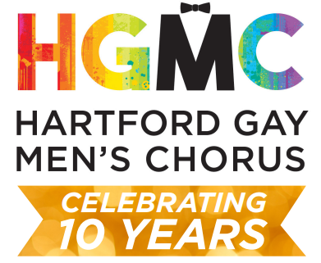

Dear Friends,

The Hartford Gay Men’s Chorus is thrilled to be in full swing, rehearsing for our upcoming Spring Concert “Singing From the Heart of Hartford”, to celebrate our 10th Anniversary Season! We have worked hard to help our community stay connected with beautiful music in a time when it was so desperately needed. We are now ready to perform in person again and need your support!

We are hoping that this season you would include us in your charitable giving or advertising/marketing efforts with an ad in our program book. These advertisements help offset the large costs of venue, costumes, music and staffing. This will also give you/your business exposure to our patrons this season. Your advertisement will reach all concert attendees, visitors to our website, our patrons, family & friends!

A lot of hard work has gone into planning and rehearsing for this concert. As we celebrate our 10th Anniversary Season, we look forward to growth in all aspects! We are now over 35 members strong and are moving in a positive direction in fulfilling our mission to use music as a catalyst to inspire, impact and enrich the lives of our members, patrons, and the community!

At our spring concert, we are happy to be performing again on June 4th and 5th, at the Aetna Theater in Hartford, CT! We appreciate you taking the time to consider supporting the HGMC with a Program Ad and we look forward to hearing from you!

Best Regards,

Alex D. Bowen
Development Director - Hartford Gay Men’s Chorus
abowen@hgmc.org • 203-715-3514

ADVERTISEMENT ORDER FORM

Thank you for advertising in the HGMC Spring Program! Please fill in the below information and submit this form with Digital Ad Copy/File, & Payment to Alex D. Bowen abowen@hgmc.org

Completed Forms, Payments and Digital Ad Copy are due by Monday, May 2nd 2022 .
Please note that all ads will only be reproduced in black and white unless otherwise specified, and logos or graphics will be accepted in black and white by e-mail. All files must be formatted as a minimum actual size image quality of 300 DPI and in a .jpg, .tif, .pdf, or .eps file type . Proofs will not be available for review prior to publication.

Business Name: ____________________________________________________________________
Contact Name: ____________________________________________________________________
Street Address: ____________________________________________________________________
City: __________________________________ State: ________ Zip: ______________
Phone Number: ____________________________________________________________________
Email Address: ____________________________________________________________________

Please select the size from below for your advertisement. Please note the orientation of width and height.
(All payments by check should be made payable to: HGMC at the below address)
______ Full page program ad (5W” x 8”W) $295.00
______ Half page program ad (5”w x 3.875”h) $150.00
______ Quarter page program ad (2.375”w x 3.875”h) $95.00
______ Contribution in place of an ad in the amount of $______________

If you have questions about payments or need a different payment method please reach out to our Director of Development: Alex D. Bowen 203-715-3514 | abowen@hgmc.org

Thank you for support of the HGMC!

